Name: Rajat Singh

Reg. No.: 22MCA0139

**DBMS LAB ASSIGNMENT**

**Q1> Implement the following object diagram and test the implementation in a PL/SQL block.**

**Solution:**

**Q2> Implement the following object-oriented diagram relating to assets in a computer laboratory. Execute insert statements for entering data into the tables so created.**

**Q3> Implement the following object-oriented diagram relating to assets in a computer laboratory. Execute insert statements for entering data into the tables so created.**





**Q4> Giant Travel is a well-known travel agency that operates guided tours. With offices around the world, they maintain accurate and detailed employee data. The employee data are kept in an object Employee_T and can be divided into two child objects: Guide_T and Admin_T. An employee can be categorized as a guide or an administration staff, but he or she can also be both. This is important because in the peak season, an administration worker might be needed to guide the tours and vice versa. The objects and the attributes are shown below.**

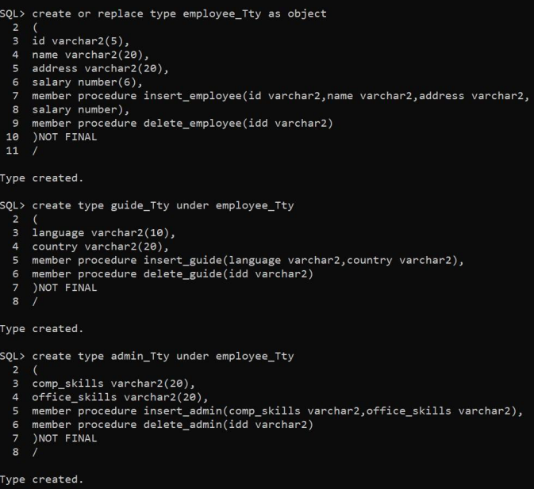

**Q5> The following figure shows the relationship among objects Supervisor_T, Student_T, and Subject_T in a university. A student can take many subjects, and a subject can be taken by many students. For every subject a student takes, there is a mark given. In another relationship, a student can be supervised by only one supervisor, but a supervisor can supervise many students. Assume that objects have been created and the tables from these objects are shown.**





